Built for the End of the World
Description | Look, I work in a nuclear facility and my PRIMARY worry is that my laptop won't survive if a disaster occurs. While I was watching Evangelion, I saw that they were using a particular laptop that looked quite sturdy. I think this is the laptop that would ease all my worries. Can you find out what laptop it is so that I can go out and buy it? I just need the model number.
Files | scene.jpg — one unaltered anime frame. Film image © khara.  Submit RCC{model}. The model family is enough; no generation or configuration suffix is required.
Hint(s) | 1. The case, hinge, and controls may tell you more than the software on the screen.  2. This is the Paris operation at the beginning of the final Rebuild film. Follow the real hardware used by WILLE.  3. Panasonic's Evangelion history distinguishes this rugged convertible from the other laptop featured in the films.
Walkthrough | 1. Reverse-search the frame or search for Evangelion Paris laptop. ITmedia's article places the computer in the opening Paris operation of Evangelion: 3.0+1.0 and identifies it as a likely Panasonic Toughbook CF-19.  2. Compare the central screen hinge, protected corners and speaker grille with the article's real product photograph. The Panasonic brochure shows the same convertible family and prints TOUGHBOOK CF-19 on its cover.  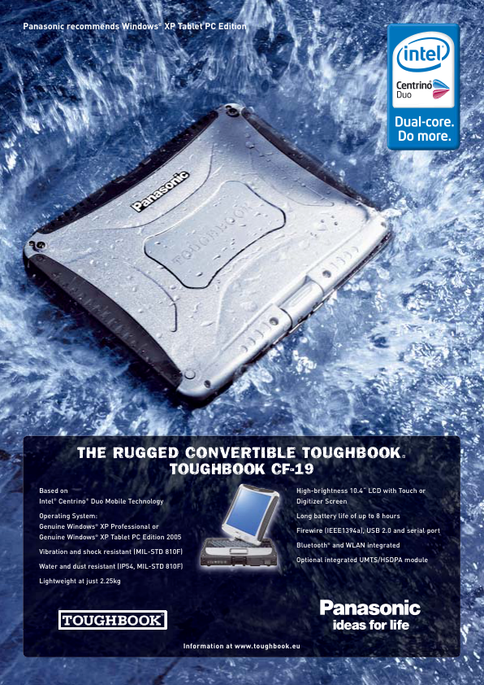  3. Open Panasonic's Evangelion history and find HISTORY 04: WILLE支給ノートPC. Its model is CF-19 タフブック and its film is シン・エヴァンゲリオン劇場版. The preceding CF-F8 entry belongs to a different film; the requested model is CF-19.
Flag | RCC{cf-19}

